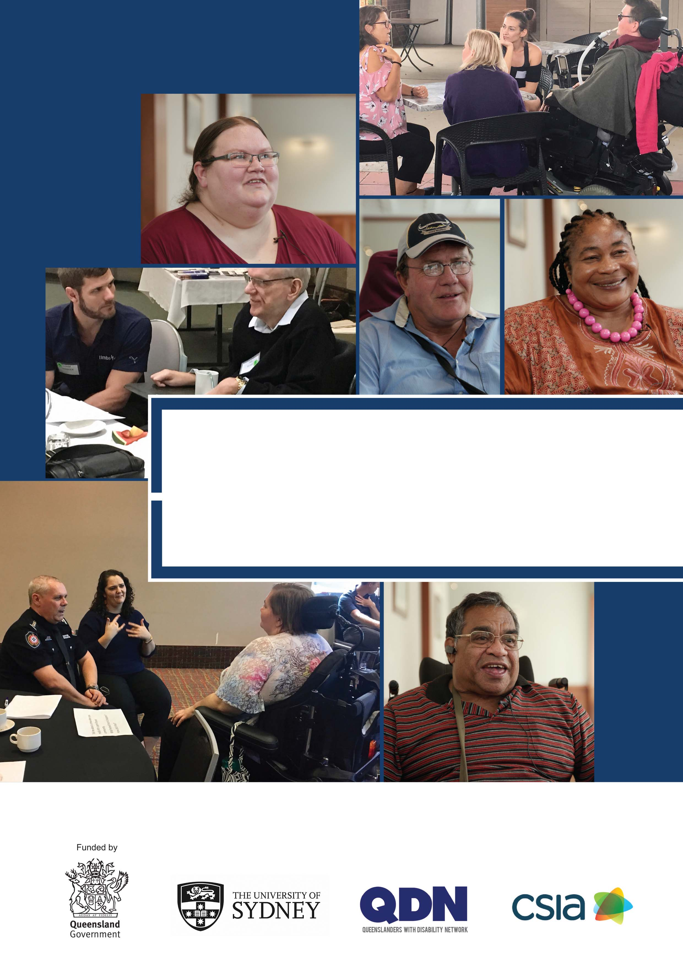

Person-Centred Emergency
Preparedness (P-CEP) Workbook
A conversation guide used by people with disability to tailor emergency preparedness planning to their individual support needs.

This Person-Centred Emergency Preparedness (P-CEP) Workbook was co-designed with people with disability.

It outlines four steps to increase emergency preparedness.

It is helpful to think of these steps as a series of planning conversations. Each step provides information, resources, and guidance to get the emergency preparedness conversation started. Each planning conversation results in self-assessment and actions to increase personal emergency preparedness. People with disability can use this P-CEP Workbook to tailor emergency preparedness planning to their support needs – so they know how they will act together with their support network in an emergency.

Tailoring emergency preparedness to the needs of people with disability can be supported by others who have knowledge, skills, and training in P-CEP planning conversations. Those people may be peer support leaders; community, health, or disability providers; or emergency services personnel.

Peer Support Leaders trained in P-CEP Peer Support have already taken steps to advance their own emergency preparedness plans. These peer leaders can help others to get prepared through peer support and mentoring.

Funding: This project was proudly funded by the Queensland Government through the Queensland Disaster Resilience Fund (QDRF) and the Department of Communities, Disability Services and Seniors,
This project was led by the Centre for Disability Research and Policy at The University of Sydney in partnership with the Queenslanders with Disability Network (QDN) and the Community Services Industry Alliance (CSIA)
Original illustrations of the P-CEP framework, Natural Hazards and Emergency Services by returnstudios.org
Citation: Villeneuve, M., Abson, L., Yen, I., & Moss, M. (2020). Person-Centred Emergency Preparedness (P-CEP) Workbook. Centre for Disability Research and Policy, The University of Sydney, NSW 2006
ISSN: 2652-2241, Issue 2/No 1 (Online)

Contents

Investigator Team ................................................................................................................... 04

Development of the P-CEP Workbook ……........................................................................... 05
Preparedness is a Process
• Using the P-CEP Workbook
• Person-Centred Emergency Preparedness (P-CEP) Planning Conversations

Getting Started with Person-Centred Emergency Preparedness ...................................... 06

STEP 1 Identify your strengths and support needs in everyday life .............................. 10
- Self-assess your strengths and recognise how you manage your
support needs every day.
STEP 2 Know your level of preparedness and learn about your disaster risk ............... 23
• Your local hazard risk;
• Getting emergency information and alerts;
• Emergency service agencies and what they do;
• The role of government in emergency preparedness and disaster
management; and
• Your responsibility before, during and after disaster
STEP 3 Make a plan for how you will manage your support needs in an emergency ... 35
• My Personal Emergency Preparedness Plan
– Be Aware
– Get Organised
– Make it Fit
STEP 4 Communicate the plan with the people in your support network and
address gaps through collaboration ................................................................. 48

Resources ............................................................................................................................... 50

Investigator Team

Queenslanders with Disability Network (QDN) Peer Leaders
Rebecca Bellis
Donna Best
Bev Best
Warwick Best
Nadia Brady
Sharon Boyce
Rob Ellis
Peter Gurr
Charmaine Idris
Esperance Kalonji
Lisa Mahony
Wayne Maitland
Gary Matthews
Rachel Matthews
Matt McCracken
Wilfred Prince
Will Proctor
Marion Rowley
Des Ryan
David Swift
Peter Tully

Advisory Committee
Aged and Disability Advocacy Australia
Amparo Advocacy Inc.
Australian Red Cross
Community Services Industry Alliance
Department of Communities, Disability Services and Seniors
Local Government Association of Queensland
Moreton Bay Regional Council
National Disability Insurance Agency
National Disability Services
Office of the Inspector-General Emergency Management
Queensland Health
Queensland Alliance for Mental Health
Queensland Council of Social Service
Queensland Disability Advisory Council
Queensland Family and Communities Association
Queensland Fire and Emergency Services
Queensland Police Service
Queensland Reconstruction Authority
Redland Regional Council

Principal Investigator
Associate Professor Michelle Villeneuve
Centre for Disability Research and Policy
The University of Sydney
michelle.villeneuve@sydney.edu.au

Steering Committee
Diana Young, Director
Strategy & Engagement Community Recovery
Queensland Department of Communities,
Disability Services and Seniors
Diana.Young@communities.qld.gov.au
Michelle Moss, Business and Operations Manager
Queenslanders with Disability Network (QDN)
MMoss@qdn.org.au
Louise Abson, Project Officer
Queenslanders with Disability Network (QDN)
labson@qdn.org.au
Matthew Gillett, General Manager Programs
Community Services Industry Alliance (CSIA)
mgillett@csialtd.com.au
Melissa Dower, Manager, Industry Excellence
Community Services Industry Alliance (CSIA)
mdower@csialtd.com.au
Laura Turner, Director
Return Studios
creative@returnstudios.org

Research Support
Ilan Ivory, Senior Communications Strategist
The University of Sydney
Ivy Yen, Senior Research Assistant
The University of Sydney
Cresta Markovic, Research Assistant
The University of Sydney

Acknowledgement
We are grateful to all of the Queenslanders with Disability Network (QDN) Peer Leaders whose insights gave shape to this Workbook. We are especially indebted to Nadia Brady, Charmaine Idris and Peter Tully for their contributions and detailed reviews; Ricky Buchanan, Bedridden Disability Advocate who put these P-CEP steps into actions that worked; Tara Collyer and Carol Nicol who contributed lived experience of disability and disaster management to support QDN Peer Leaders to develop their preparedness plans. Numerous emergency services personnel applied their experience and expertise to co-design Step 2 of this Workbook – We thank Queensland Fire and Emergency Services (QFES), Fire and Rescue NSW, and Country Fire Authority Victoria.

Development of the P-CEP Workbook

The Person-Centred Emergency Preparedness (P-CEP) Workbook is part of a growing suite of tools developed to enable people with disability to make emergency preparedness plans that are tailored to their individual support needs. A series of videos provide illustration of P-CEP in action.

We developed this Workbook through a co-design process including Queenslanders with Disability Network
(QDN) Peer Leaders, disability advocates, and emergency management personnel from agencies in Queensland, NSW and Victoria. It was field tested with 25 people with disability.

This Workbook is part of an ongoing project to develop a P-CEP Peer Leadership Program. The following figure provides an overview of the co-design methodology which integrated knowledge creation with knowledge application (Graham et al., 2006).

Methodology
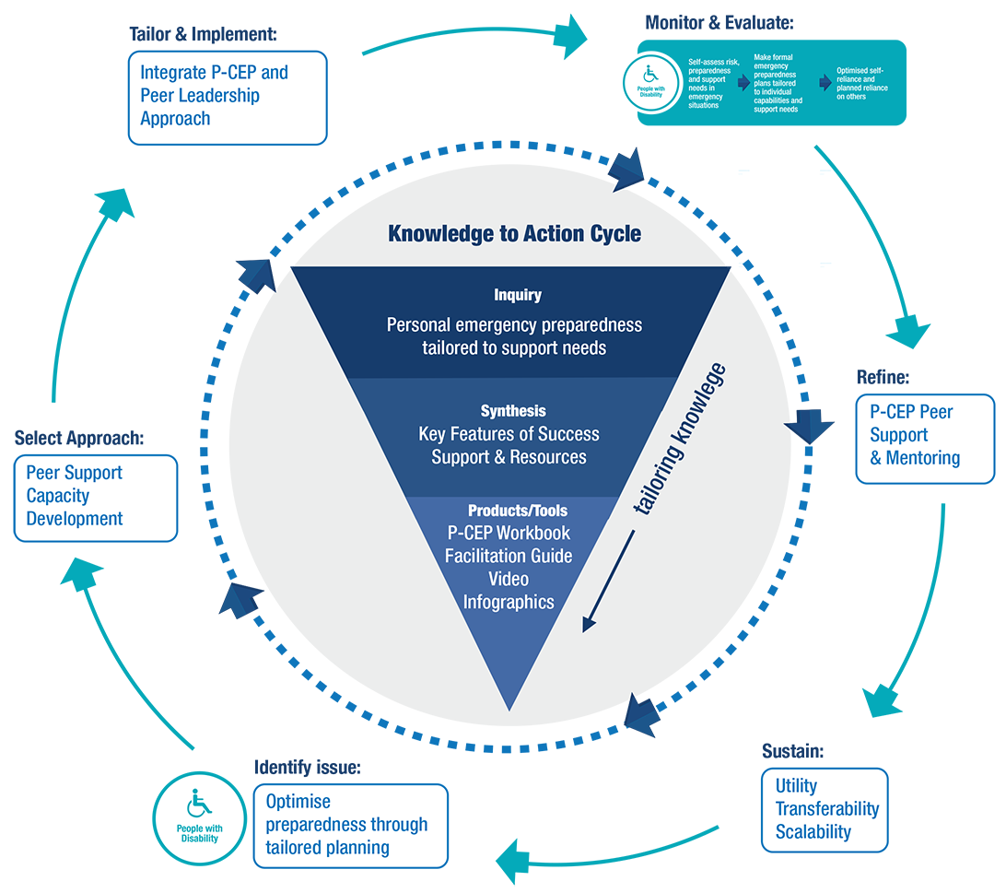

The collection of P-CEP tools and resources can be found here:
www.collaborating4inclusion.org/PCEP/

Preparedness is a process, not a one-time event!
Emergency preparedness means taking steps to make sure you are safe before, during or after a natural hazard or other emergency (e.g., house fire; pandemic). Some people with disability need tailored emergency preparedness plans that take into consideration how they will manage their unique support needs in emergencies.

Personal preparedness is the most important thing anyone can do to make sure they are safe in an emergency. Being prepared helps people to respond better and recover faster. We all need to be ready and know what to do. The Disaster Risk Management cycle has four phases: prevention, preparedness, response, recovery. There are actions that people with disability can take to increase their resilience to disaster in each phase.
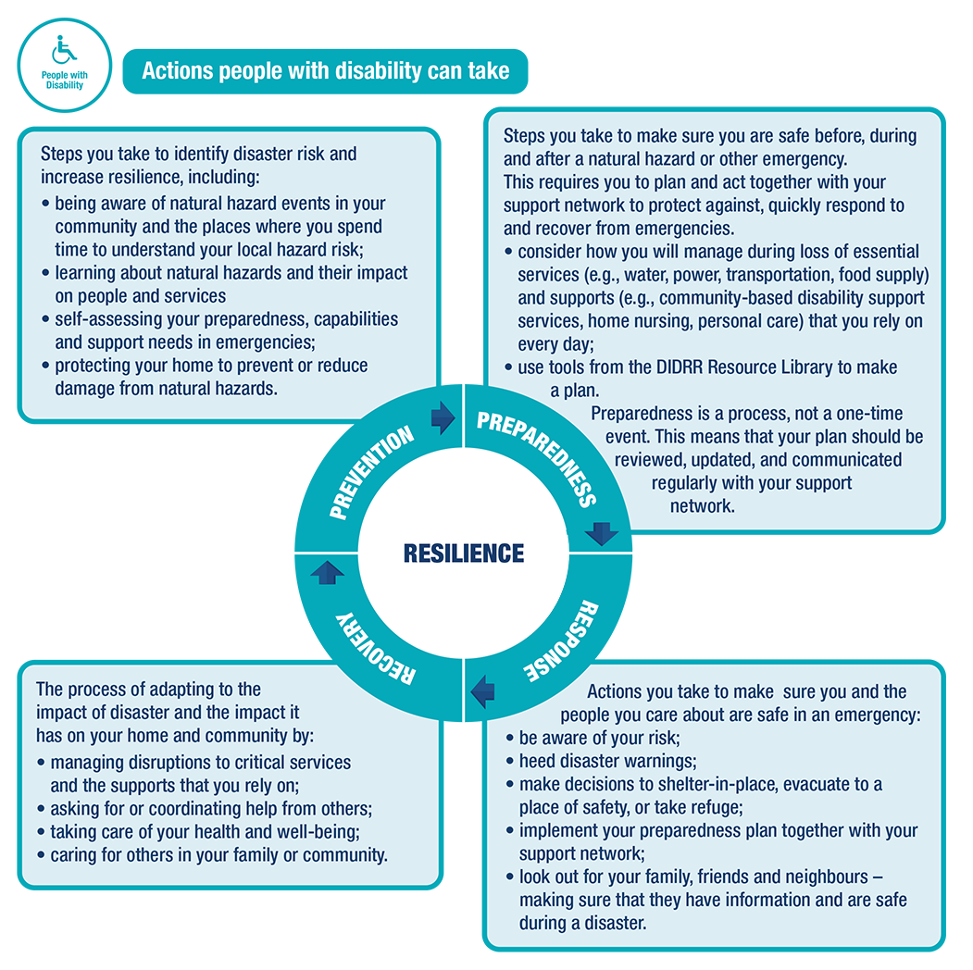

FACT: People with disability manage every day in environments that are often inaccessible. They develop their own strategies for using their strengths and managing their support needs in ways that work for them. They regularly adapt to changing situations. These are strengths that people with disability bring to emergency preparedness.

Disability Inclusive Disaster Risk Reduction (DIDRR) means making sure the needs and voices of people with disability are included in how governments and emergency service agencies to plan for and manage disaster risk.
The Queensland DIDRR Framework provides steps that different stakeholders can take to increase the resilience of people with disability to disaster.

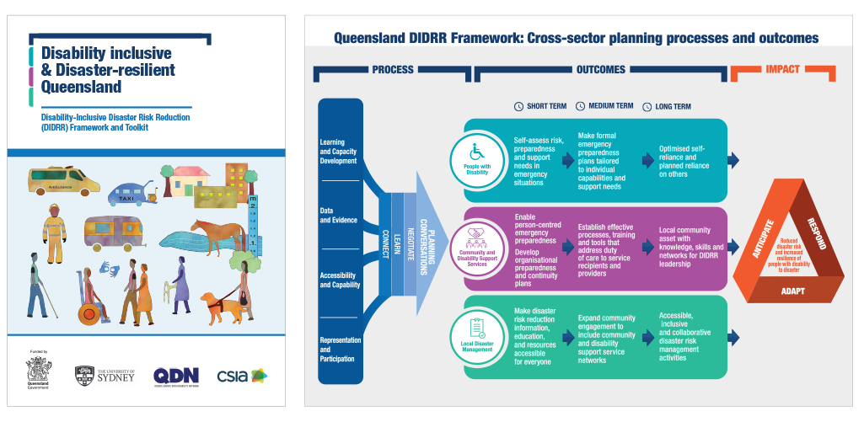

The Queensland DIDRR Framework and Toolkit can be accessed at: www.collaborating4inclusion.org

One important part of the DIDRR Framework focuses on actions that people with disability need to take in order to increase their personal emergency preparedness. That is the focus of this P-CEP Workbook.

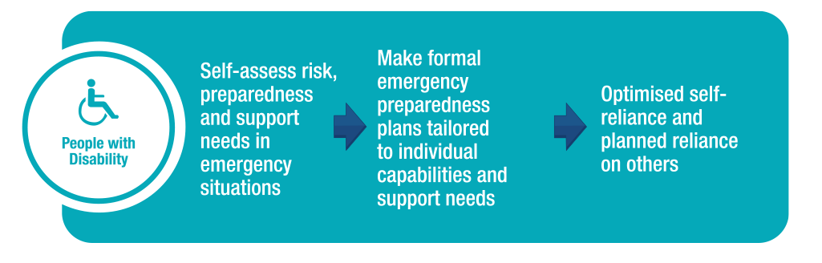

Using this P-CEP Workbook

Having an emergency preparedness plan means knowing how you will act together with your support network
before, during, and after a disaster.

By using this workbook, you can create a realistic plan.

A realistic emergency plan considers:
- your individual strengths, support needs, and situation;
- steps you have already taken to prepare;
- gaps in your preparedness that increase your risk in emergencies; and
- ways to address the gaps.

This Workbook helps you take steps to increase your personal emergency preparedness. Prompts and tips
help you to get started by considering your current stage of preparedness and helping you get to the next level.
Spaces are provided to document your learning, reflections, and action plans.

Information about emergency services and disaster warnings is provided to:
- learn about local hazard risk,
- be aware of disaster warnings,
- know where to go for information; and
- make good decisions before, during, and after a disaster.
Person-Centred Emergency Preparedness Planning Conversations

Planning conversations start with you and your support network (e.g., family, friends, peers) talking about what
you need to be safe before, during, and after an emergency.

Your job is to make a plan for how you will act together with your support network in emergency situations.
The Person-Centred Emergency Preparedness (P-CEP) framework helps you to think about your strengths and
support needs in these eight areas:
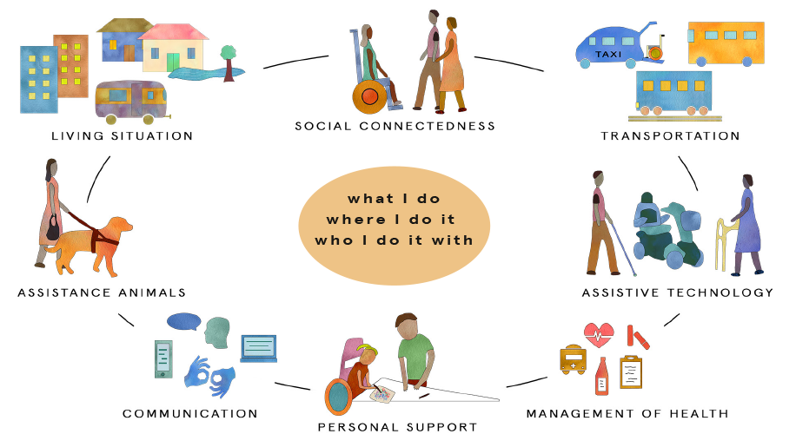

Person-Centred Emergency Preparedness (P-CEP) Capability Wheel
Published with permission (www.collaborating4inclusion.org)
Getting Started

This workbook breaks P-CEP planning down into four action steps.

Think of each step as a planning conversation.

These four actions are not going to happen in one day.

Work through the P-CEP at your own pace.
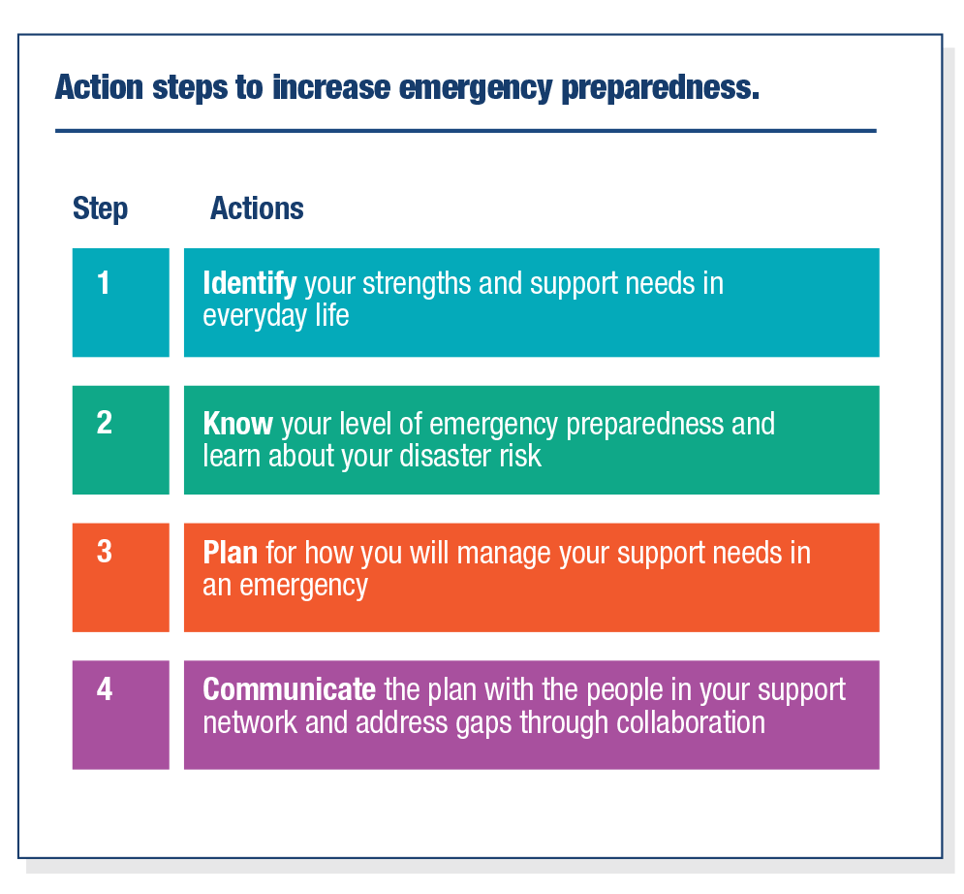

Support from others is important.
You should reach out to others in your community to get the information and support you need.

1
Identify your strengths and support needs in everyday life

Knowing how you manage every day is the first step in planning for how you will manage in an emergency. In this step, think about what your support needs are in your day to day life, not in an emergency.

This will help you with your emergency planning when you get to Step 3.
First, think about what you do; where you do it; and who you do it with.
Think about your roles and responsibilities in everyday life.

For example, your schedule might include:
Work, volunteering commitments
Meetings
Gym, exercise
Scheduled social engagements
Support worker schedule
Therapy appointments
Medication
Other family members leaving for work and coming home

A typical day for me looks like this:
Notes:

1

Next, use the Person-Centred Emergency Preparedness Framework or “Capability Wheel” to think about your strengths and discuss how you manage your support needs every day. Start where you like and go around the Capability Wheel.
Focus on the elements that are relevant and skip the ones that do not apply to you.
Consider how you manage your support needs every day. Think about:
– What do you do for yourself?
– What do you rely on others for?

On the following pages, definitions are provided for each area of the Capability Wheel.
Prompts are used to guide self-reflection.
Spaces are provided to write down your ideas.

Person-Centred Emergency Preparedness (P-CEP) Capability Wheel
Published with permission (www.collaborating4inclusion.org)

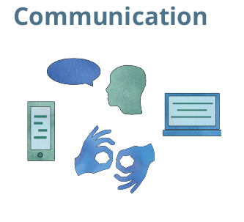
Getting, giving and understanding information.
It includes the use of *Augmentative and Alternative Communication (AAC)1. It is also the means of sending or receiving information such as telephone (landline; mobile) or computers.

1

Notes:

Consider:
- What support do I need for seeing, hearing, speaking, understanding?
- What assistive devices, tools, technologies, or services do I rely on to communicate?
- How do I best communicate? (e.g. Auslan, written communication, Braille etc.)
- How do I usually go about getting information?
- Things that help me talk? (e.g. communication system, gestures, pictures, people, etc)
- Things that help me understand? (e.g., pictures, simple words, showing me, etc)
- What support do I need to call people or get information from others? (e.g., Landline, mobile, computer, other device)
- Who/what sources do I trust to give me helpful information?
- Do I have access to a computer/internet/data?

1 * AAC are communication methods used to supplement or replace speech or writing for those with impairments in the production or comprehension of spoken or written language.

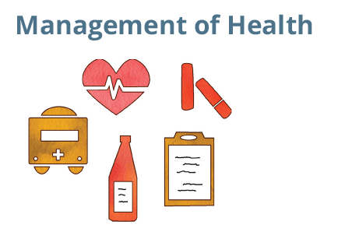
Taking care of your health.
The medical management of your condition which may include medicines, nutritional, exercise, health or other treatments or therapies that help you to maintain your well-being. This also includes how you look after your mental health.

Medical management includes management of wounds, catheters or ostomies; access to medical supplies, equipment or their maintenance; operating power-dependent equipment to sustain life.
1

Notes:

Consider:
- Where do I keep my health information? (e.g., identification, Medicare, health records)
- What are my health conditions/exercise/nutrition needs?
- How do I manage and monitor my health/medical/treatment?
- What power sources are needed to operate my medical equipment (e.g., battery, electricity)?
- Who helps me?
- Where do I get my supplies?
- How do I manage my supplies?
- What treatments/therapies are important for my physical health, my mental health and well-being?
- Do I have private health insurance? What services are covered by my insurance?
- Who is my doctor? What other health professionals or services do I rely on?
- Who is my local chemist?

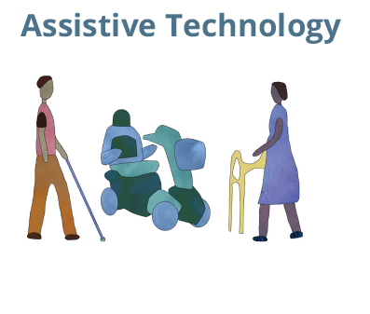
1
The help you get from equipment.
Assistive technology is any device, system or design, that allows you to perform a task that you would otherwise be unable to do. Assistive technology can increase safety or make tasks easier to do. It can include anything (e.g., tool or device; high or low tech) that assists you to carry-out your daily activities.

Consider:
- What assistive devices, technology, or equipment do I use?
- What supplies do I always have on hand?
- What power sources are needed to operate my equipment?
- What is required to maintain the equipment?
- Who helps me?
Notes:

My List of Equipment | Critical to my functioning? |  | Use, Maintenance or Repair Considerations
 | YES | NO

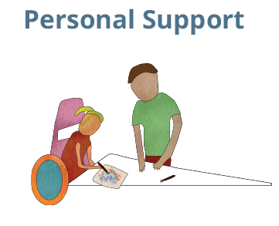
1
Help you get from other people every day.
The assistance received from another person for personal care or support with activities of daily living. It can include both practical and emotional support that enables you to do the things you want, need or have to do every day.

Notes:

Consider:
- Who helps me with my self-care/activities of daily living?
- What do they help with?
- When do they help?
- How do I organise my personal care?
- How do I manage if/when they are unavailable?

My Service Providers

Service Provider Name and Role | Organisation they work for | Phone Number | Address or Email

1

 | Yes | Make notes about the help you need
Communication
Bathing
Toileting
Grooming
Dressing
Transferring
Mobility/Positioning
Sleeping
Eating
Cooking
Cleaning
Shopping/Groceries
Managing Equipment
House Keeping
Home Maintenance

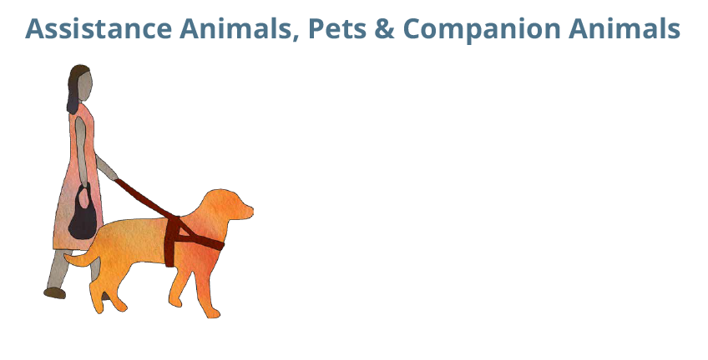
Help from animals. How you care for them.
Assistance animals provide an important service that helps some people to more fully participate in personal and public life activities with more confidence and independence (e.g., mobility guide; hearing assistance; diabetic, seizure alert or response; emotional support, etc.).

Pets and companion animals are very important to many people.
1

Consider:
Information
- What type of animal/s or pet/s do I have?
- What is my animals/s or pet/s name/s?
- Where do I keep my animal’s information,
medications, insurance?
- Do I have collar, ID Tag, and leash for my
animal?
- Evidence of my animal’s registration,
desexing and vaccinations?
- Contact details for my Vet?
Supplies
- What care does my animal need? Who helps
me to provide that care?
- Where do I get supplies for my animal?
Eating, Sleeping, Cleaning
- What food does my animal eat?
- What is important for my animal to sleep?
(blankets, bedding, nesting)
- What is important for cleaning? (litter, tray,
waste cleaning, bags)
- What is important for play? (toys, comfort
objects)
Other information
- Key commands for my animal are?
- Others should be aware about?

Notes:

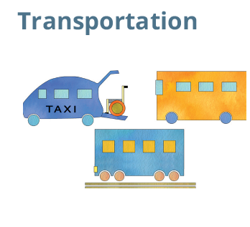
How you travel to where you want to go (e.g.,car, bus, train, taxi, walking).
How you get around from one location to another and includes independent travel and travel with others (e.g., family, support worker), including assistance animals and pets.
1

Consider:
- Where do I need to go? (e.g., work, leisure, volunteering, shopping, etc)
- How do I get to places in the community?
- Who helps me?
- Who drives?
- How do I organise my transportation?
Notes:

Me/My Service Providers

Name of Driver | Phone Number | Driver License Number | Car Registration Number

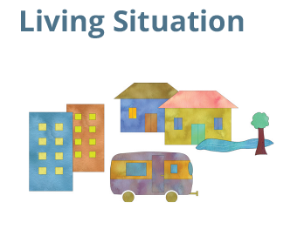
Notes:

Where you live and who you live with.
Where you live and the context of your home situation including who you live with, the type of building, how long you have lived there, the accessibility, safety, security, and adequacy of the physical environment, and the location.
1

Consider:
- Who do I live with?
- Where do I spend most of my time when I’m at home?
- How does the location of my home (city, town, rural) affect how I go about my daily activities?
- Things that make me feel safe/unsafe at my home or in my community?
- What is my water, electricity, gas supply?
- How many exits are there? Are they accessible? Is there a lift?
- Do I have functioning smoke alarms? When were they last checked?

My Important Services

Company | Account Number | Contact Details
Electricity
Gas
Water
Internet
Phone
Home/Content Insurance

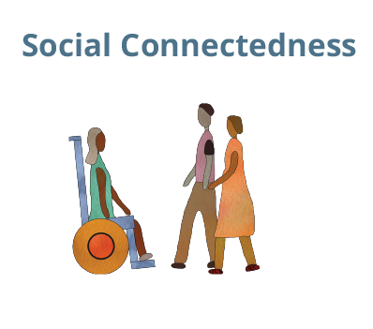
The people you do things with. Your relationships with friends, family and other people. Help you give to other people.
The relationships between you and the people in your community. These relationships may be personal (e.g., family, friend, neighbour) and/or professional (e.g., service provider, community leader).
1

Consider:
- Who is in my circles of support?
- Who do I count on?
- What type of support do they give me?
- Who counts on me?
- What type of support do I give them?
- What is the nature of my relationships with others? (e.g., How long have I known them? ; How often do we see each other?; Do they live near or far? Direction of support – I help them, they help me, both; closeness/connectedness (emotional); Am I/they judgemental or disapproving? Am I/they supportive or encouraging?)
- Where can I go if I ever need support or
a place to stay? Have I spoken to them
about this?

Notes:

My main support people

Name | Phone Number | Address | Notes

1

My Support Network
Write down the people in your life and think about your connection with them. Who do you rely on? Who relies on you? Do they live nearby or far away? How do you stay in contact?

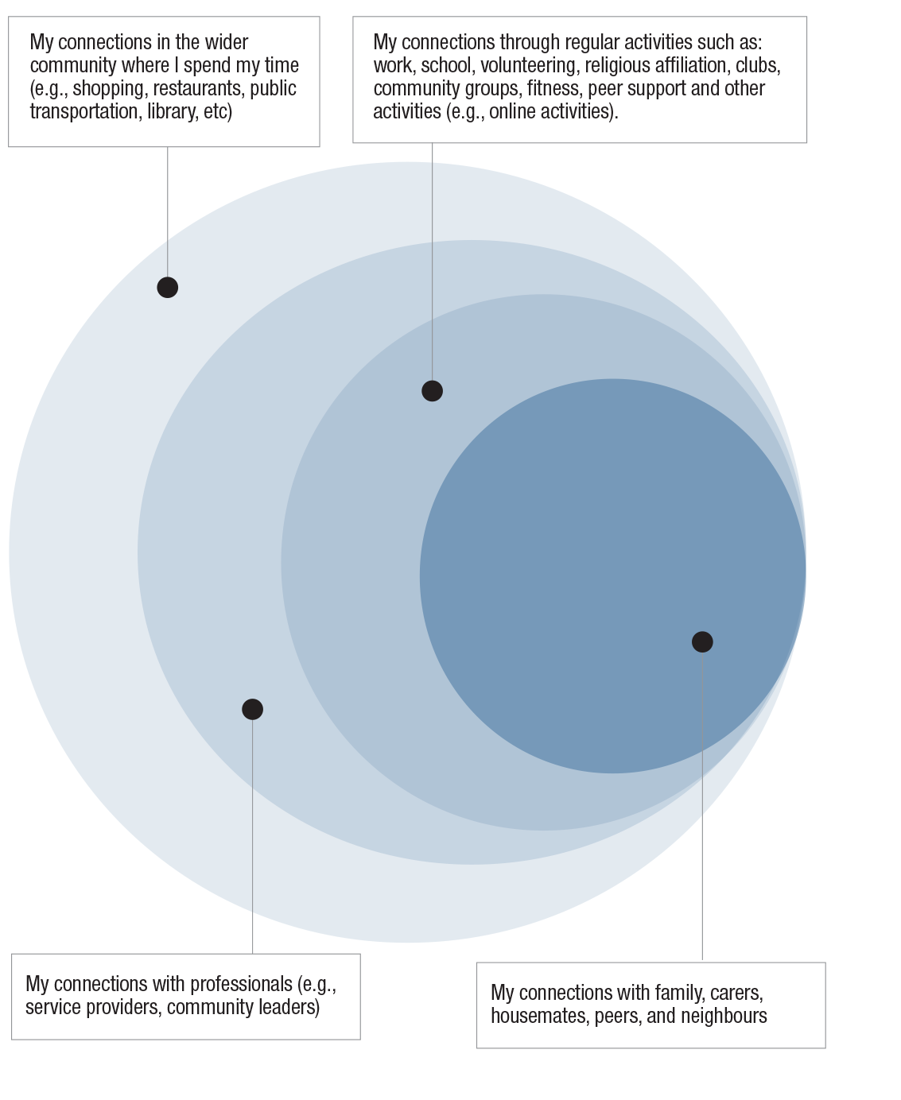

1
Document the key people you can rely on. Identify who can and who cannot provide support when you need help. Identify people you provide support for.

Know your level of preparedness and learn about your disaster risk
2

How prepared are you for emergencies?
Where are you on this diagram?

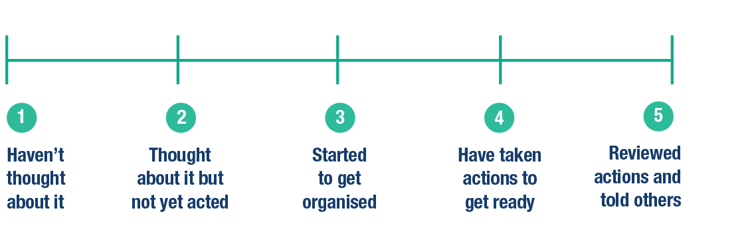

Some of us are further along on our emergency preparedness than others. Let’s face it, if you haven’t thought much about preparedness, it would be unfair to expect you to achieve level 4 or 5.

It takes time to learn about your risks and take preparedness steps.

Emergency preparedness is a process.
The goal is to increase your emergency preparedness incrementally.
You can start by identifying priority areas and taking small steps.
Start with what you can do today.

“Only a few people with disability that we spoke to had taken steps to tailor emergency preparedness to their support needs such as: documenting instructions for support workers in an emergency, holding household emergency meetings, and planning evacuation routes.
For the people who engaged in it, disability-specific planning gave them confidence that they would be able to manage in an emergency.”

2

Examples of Stage of Preparedness

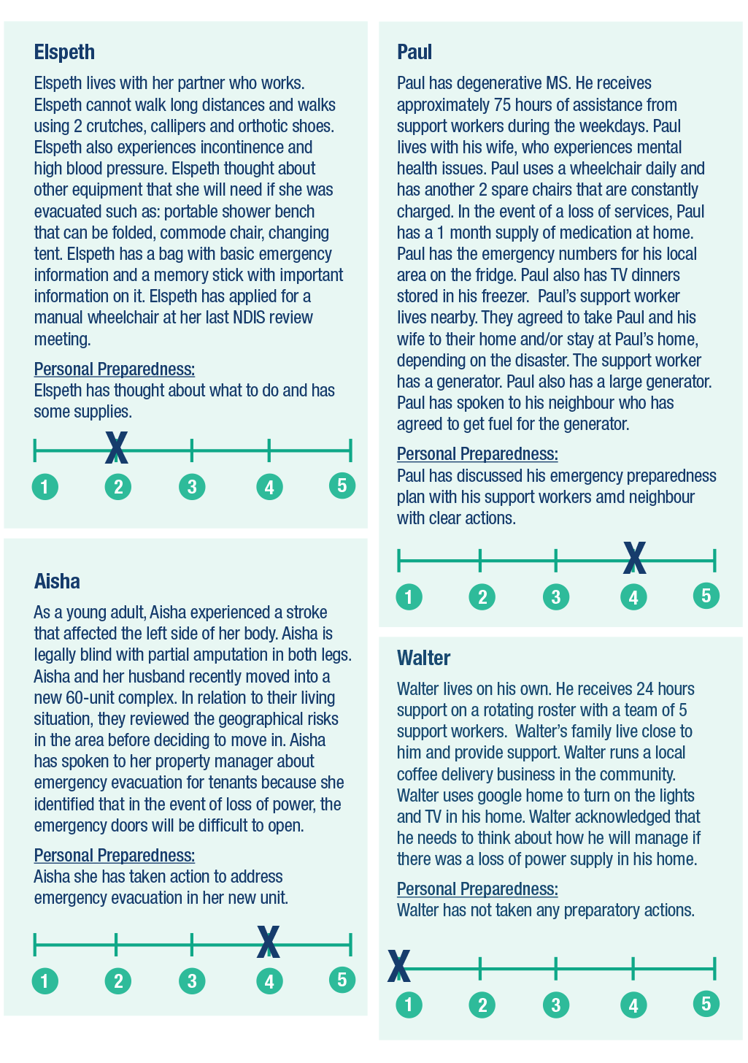

2

Learn about your disaster risk and the emergency management arrangements in your community

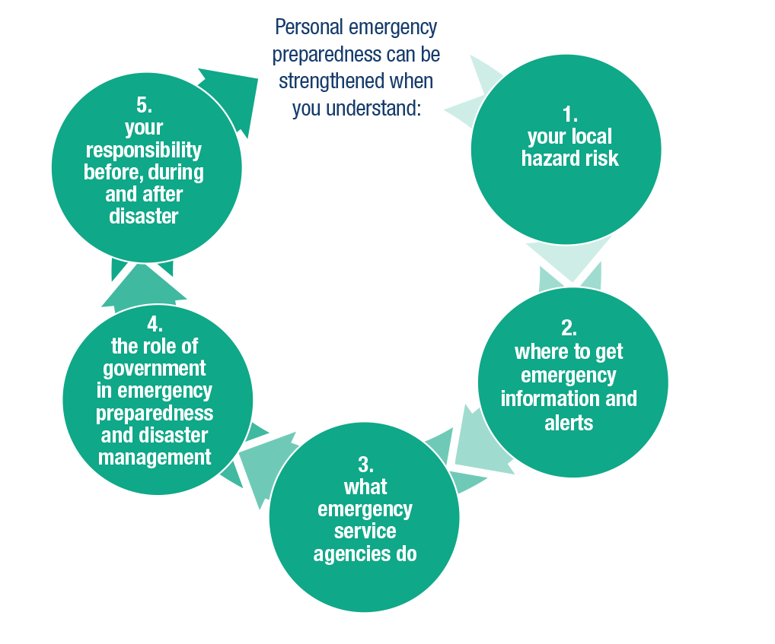

- Understanding your Local Hazard Risk

You can make a better Plan when you understand what to expect in an emergency. A good place to start is by learning about the local hazard risks in your community.

Visit your local council website to learn about the local hazard risks where you live. If you do not have internet access, you can call and talk to someone at your local council to ask about the hazard risks where you live, work, and spend time.

2

My emergency risks:

What are the main risks in your community?  (check ones that apply) | How would the emergency affect you?
Heatwave
Storm
Cyclone
Bushfire
Flood
Earthquake
Tsunami
Landslide
House fire
Power outage
Health emergency (e.g., like COVID-19 pandemic)

You can learn more about the different types of local hazards and how to prepare for them. Use the information guides and links provided below to plan to protect your life and property.

2

Natural Hazard Preparedness Information:

https://www.abc.net.au/news/emergency/plan-for-an-emergency/heatwave

https://www.abc.net.au/news/emergency/plan-for-an-emergency/flood/
https://www.abc.net.au/news/emergency/plan-for-an-emergency/bushfire/
Bushfire information guide (easy read) https://cid.org.au/resource/bushfire-info-guide-nsw/?fbclid=IwAR3Y-nUZ0MYZNQYcA8VCIhE73LZRNX2h9UociwYAICtGVCq9Zx6hnlDAIuw

https://www.abc.net.au/news/emergency/plan-for-an-emergency/cyclone/
https://www.abc.net.au/news/emergency/plan-for-an-emergency/storm/
https://www.abc.net.au/news/emergency/plan-for-an-emergency/earthquake/
https://www.qld.gov.au/emergency/dealing-disasters/disaster-types/tsunami

https://www.qld.gov.au/emergency/dealing-disasters/disaster-types/landslides

2

3 steps to home fire safety: https://www.qfes.qld.gov.au/fireescape/
Are you fire safe at home? https://www.fire.nsw.gov.au/page.php?id=289
Contact your local fire station for information and advice on home safety.

Power outage can happen at any time. It can be caused by heatwave, storms, and bushfires
https://emergencyprepare.com.au/power-outage/
Pandemic
The Australian Government Department of Health has advice for people with disability here:
https://www.health.gov.au/news/health-alerts/novel-coronavirus-2019-ncov-health-alert/advice-for-people-at-risk-of-coronavirus-covid-19/coronavirus-covid-19-advice-for-people-with-disability

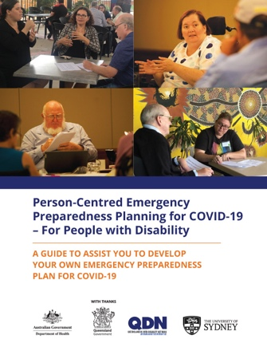
A P-CEP COVID-19 Planning Guide was developed to assist people with disability to know their risk, make a plan, and stay connected.
That resource can be accessed here:
www.collaborating4inclusion.org

What was the impact of the COVID-19 social isolation and other restrictions for you?

2
- Where to get emergency information and alerts

The ABC is Australia’s Emergency Broadcaster.

The ABC provides information about disasters and other emergencies.
They also support the communication of emergency Alerts and Warnings.
The ABC Website provides Alerts and Warnings at this link: https://www.abc.net.au/news/emergency/
You can keep up to date on weather information and emergencies in your area by listening to ABC Radio. Use the ABC Radio Frequency Finder at this link to find the ABC Radio Frequency near you: http://reception.abc.net.au
The ABC Emergency Facebook page shares information about emergency news coverage across Australia: https://www.facebook.com/ABCemergency/.
The Facebook page does not share all disaster alerts and warnings.
The ABC Emergency Twitter page shares the latest weather, emergency information, and alerts from around Australia https://twitter.com/ABCemergency
People need to be aware and use their own observations about any approaching hazards.
Individuals should be prepared and have an action plan.

Each State has information on government websites to help you get ready for emergencies. For example:
Get Ready Queensland:
https://www.getready.qld.gov.au/get-prepared/3-steps-get-ready

PREPARE Western Australia
https://www.dfes.wa.gov.au/emergencywa/prepare.html

Emergency Preparation South Australia
https://www.sa.gov.au/topics/emergencies-and-safety/prepare-for-an-emergency/are-you-prepared-quiz

Prepare Northern Territory
https://securent.nt.gov.au/prepare-for-an-emergency

Many Councils have a Disaster Dashboard. Disaster Dashboards provide up-to-date information and facts about disasters in your area. Visit your local Council website Disaster Dashboard to see what information is available.

- Emergency Services: Who are they and what they do
2

In a life-threatening emergency, you should always dial “000.”

In an emergency, people need to be prepared and know what to do. During an emergency, emergency services must focus on managing the hazard and keeping the whole community safe. Emergency services do not have a rescue boat or fire truck in every community.

Emergency services do play important roles in keeping communities safe before, during, and after a disaster. Emergency services work to reduce disaster risk for individuals and communities.
Planning for different scenarios means taking into account what you do, where you do it, and who you do it with – because disasters can happen at any time and any place. There can also be a number of different disasters at one time.

When we are prepared and respond effectively, we help emergency services to focus their efforts to manage the disaster and its impact.

Emergency services:
• provide advice and information to help you prepare for emergencies
• issue warnings to help you act in time
• temporarily repair property damage when there are safety and access issues

2

Agency and their main role

State Emergency Services (SES)
Leads management of floods, storms and tsunami
Rural Fire Service (RFS)
Leads the management of bushfires and other fires in rural areas
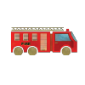
Fire and Rescue
Leads the management of house fires in major cities and towns.
Plus manage industrial fires, hazardous materials and rescue
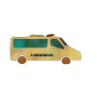
Ambulance
Leads the management of health and medical emergencies
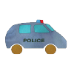
Police
Leads the management of crime and public order, plus search and rescue via air,
land and sea

In emergencies, their roles can overlap. In a big emergency, you may see different emergency service staff and volunteers working together. For example, both SES and RFS have floodwater rescue capability, and Fire and Rescue Services will often be involved in bushfire response alongside RFS when houses are under threat.

There are fire service agencies in each state and territory. For example, QFES in Queensland, CFA in South Australia, and RFS in New South Wales. Many firefighters are volunteers.

Visit emergency services websites in your State to learn more about your local hazard risk and steps you can take to get ready

2
- The role of government in disaster risk management

Government facilitates emergency management planning and coordinates relief and recovery support for people affected by disaster.

They make sure people have information so they can learn about:
• their local hazard risk;
• things they can do to protect themselves, their property, animals and livestock; and
• steps they can take to get ready for emergencies.

Governments have responsibility to make sure that this information is accessible in multiple formats so that everyone can understand and use it.

Local Councils work closely with emergency services and community organisations before, during, and after disasters to address the well-being of people in their community. They are supported by regional/district, state, and federal government.

Local governments establish local emergency or disaster management groups. Local Disaster Management Groups make plans for how they will manage risks in the community. The Local Disaster Management Plan tells how local councils will work together with other government agencies, emergency and community services in a disaster.

Visit your local Council’s website to learn about the emergency management arrangements in your community. In regional or remote areas with small Councils, websites might be limited and hard to navigate. So, contacting your Council directly might be a better option.

Tips:
You can help your local Council to make information more accessible by telling them about:
emergency information and resources that you can access and find helpful; and
what information you need and how they can make it more accessible for you.

Do you know the emergency plans for:
your local Council area?
your workplace?
your children’s school?
your support provider?

2
- Your responsibility before, during and after disaster

You also have responsibilities before, during and after disaster.

You must:
Learn about your hazard risk;
Have a plan and take responsibility for your own safety in a disaster. That plan must include the people
in your support network
Be Aware: Stay alert for any hazards.
Heed warnings by acting together with your support network in an emergency

You are already taking important steps to decrease your disaster risk when you:

Reflect on your current level of preparedness and learn about how disasters will impact you.
(Step 2)
Self-assess your strengths and support needs.
(Step 1)

This workbook goes one step further by helping you to fit emergency preparedness to your unique support needs and situation.

In Step 3, you will use what you have learned to make a plan for how you will manage your support needs in emergencies.

“The woman I talked with uses an electric wheelchair and she also has a hearing impairment. She has lived in a lot of disaster areas. So, she has a generator, she has two weeks of food on stock. She has her meds prepared; she has two levels of disaster packs. So, first level she has a USB that she carries that has all of her information on it, her medical information, everything, and the second thing is a waterproof case with all documents near the door, to have that if she needs to evacuate.”

There are things that everyone should do to plan for emergencies:
People with disability may need additional support, resources or advocacy to prepare.

2

The following questions were asked by people with disability. These questions can help to guide your self-assessment and preparedness planning.

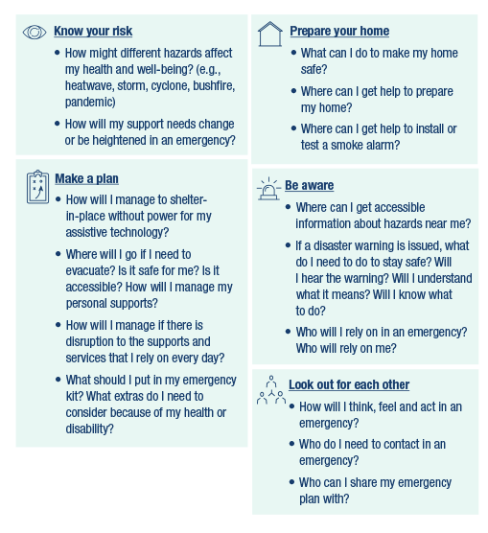

3
Make a plan for how you will manage your support needs in emergencies

Step 3 asks you to think about how you will manage your support needs in an emergency.

First, think about:
the support needs you identified in Step 1; and
what you learned in Step 2 about how emergencies might impact you;

Next, consider these two scenarios. Think about what you would need to manage in each scenario.

Scenario 2: Go
What if I had to
shelter-in-place for up
to 7 days or longer without access to the services and supports I rely on?
Scenario 1: Stay
What if I had to
shelter-in-place for up
to 7 days or longer without access to the services and supports I rely on?

“So, if you’re going to be sheltered in a place for a long-term period, is that place going to be suitable for you? Or, if you have to evacuate, knowing the how, where, and who. How are you going to get there? Where is it? And who’s going to provide the assistance you need?”

Make a personal emergency preparedness plan by doing these three things:

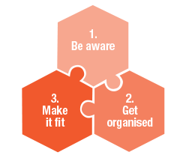

My Personal Emergency Preparedness Plan
3

Name
Address
Phone Number
Language Spoken

Be aware!
In life threatening emergencies

POLICE/FIRE/AMBULANCE
000

Hearing/Speech Impaired SMS relay number
0423 677 767

Voice Relay number
1300 555 727

TTY number
133 677

National Telephone Interpreter Service
1800 131 450

State Emergency Services (floods and storms) | 132 500
Bushfire Information Line (Fires near me)
Police Assistance (non-emergency)
Life Line – 24 Hour Free Crisis Couselling
My Local Radio Station
My Local Council

Get Organised!
3

My personal emergency information

Name of Household member | Medicare Identification | Centrelink number | Passport number | Tax file number

Tips Identify emergency contacts. Have at least one out-of-town contact person and know their number
Identify a workplace/volunteer contact person
Make a Will
Appoint enduring Power of Attorney
Appoint enduring Guardianship
Make Advanced Care Directives
Make a financial plan

Key Emergency contacts

Name | Phone | Email Address | Relationship

My important contacts

Advocate |  | Childcare/School Contact
Power of Attorney/Guardian |  | Workplace/Volunteer Contact
Solicitor |  | Doctor
Insurer (home) |  | Specialist Practioner
Insurer (contents) |  | Private Health Cover
Insurer (vehicle)

Other people I can rely on in an emergency

Name | Phone | Address | Relationship
“That person felt very confident about how things would progress if there was an emergency because she had an awareness that she knew what she would take from her apartment.”
3

Create an emergency kit

Home (stay) Emergency Kit Contents:
A portable radio with spare batteries.
A torch with spare batteries
A first aid kit
Non-perishable food (e.g., powdered milk, canned foods, a gas burner for cooking if available, water)
A torch or lantern with spare batteries
Important documents including emergency contact numbers
Copies of your emergency plan
I will add the following items to my emergency (stay) kit:
________________________________________________________________
________________________________________________________________
________________________________________________________________

Evacuation (go) Emergency Kit Contents:
3-day supply of bottled water
Dietary requirements and supplies
3 – 14 day supply of medications (including prescriptions)
3-day supply of appropriate clothing and footwear
Personal care items
Blankets
Spare home and car keys
Cash and credit cards
Food and medications for your pets
I will add the following items to my emergency (go) kit:
________________________________________________________________
________________________________________________________________
________________________________________________________________

Tips Scan important documents and store on a USB or in the Cloud
Keep important hard copy documents together in a waterproof bag or container
Put documents in an easy to access location so you can “grab and go”

3

Make it Fit!

In this step, your job is to make your emergency plan fit your support needs!

Review Step 1 of this Workbook.
Think about your capabilities and support needs every day.
Now, think about how you will manage your support needs in an emergency.

Review Step 2 of this Workbook.
Think about plans you will need to put in place for different types of emergencies.
Consider how your plan will be different if you have to shelter-in-place (stay) or
evacuate to a place of safety (go).

Circle your priority areas for personal emergency preparedness:

What happens when it doesn’t fit?

“People shared their worries about how they would manage if they had to evacuate from their home. They knew that evacuation centres were not ideal. Making alternate arrangements to stay with family or friends were sometimes unrealistic because those homes were not always accessible. They wondered what options would be available for them if they need to evacuate but have nowhere to go that can support their needs.”

Thinking about evacuation might make you feel anxious too. Talk with the people you trust about the evacuation scenario. Brainstorm options that might work for you.

3
Tips for making your plan fit your support needs

“When I got evacuated, where I went, I didn’t get the accessibility options of being told where I was and where, say the bathroom was in relation to my room, which is something, being severely vision impaired, I really needed.”

Tips Create a health passport so others know the best way to communicate with you.
Examples of health passports can be found here and here
Visit this website if you need translation or interpreting services:
https://www.tisnational.gov.au/en/About-TIS-National
Visit this website for information about Indigenous interpreting services:
https://www.2m.com.au/interpreting-services/indigenous-language-interpreting/

“Her personal support details are written out for support workers because there might be an incident where there’s a change of care. So, that way, when somebody comes in, they can see it. The instructions are there, it’s very clear what’s needed. That includes also the plan of whereabouts the meeting point might be was all spelt out in her emergency plan.”

“When it comes to people with disabilities, it’s a case by case basis. I can’t dress myself; I can’t undress myself. And different people need different levels of care or are willing to accept different levels of care.”

Tips Ask your service provider about what plans they have in place for service continuity during and after
emergencies.
In an emergency, you may be separated from the people who normally provide assistance. Your
emergency plan should include a record (in whatever way is useful for you) of the support needs you
have and the support you receive to meet those needs.
Recording details about your specific support needs can assist with making effective decisions when
you are under pressure. Share the information with others who support you. Together, you can make
back-up plans for assistance in emergencies.

“I’ve got 12 hours back up electricity for my ventilator so if that’s not there. So, if there were a power outage it would be a life-threatening situation.”
3

“Because of the way my disability works; basically anything that causes my body severe stress will undoubtedly cause a flare-up that has potential to cause disease progression. If that stress is severe or ongoing (like having to evacuate or be away from my usual supports), then the risk of disease progression increases.”

Tips Remember to keep copies of concession cards, health insurance cards and prescriptions together with
this emergency plan.
Make a note of where you keep your medication in case you have to evacuate quickly and someone
needs to get it for you.
Write down instructions for people in your support network so they can help you collect what you need
if you have to evacuate.
Discuss with your doctor how you will access controlled medications during and after an emergency
Think about any medical devices you need (e.g., blood pressure monitor; insulin; extra glasses; hearing
aids).
Your emergency plan should include a detailed record of the things you need to manage your health.
This list is important, so you don’t forget what you need (things like: prescription medication; catheters;
feeding tubes; CPAP; filters)
Remember to put supplies you need for your health in your emergency kit (e.g., catheters; bags;
feeding supplies, etc)
Register for MyGov (https://my.gov.au)
Seek support from your health practitioner to make sure you have the information and support you
need to manage your health in emergencies. For example, if you have to skip or delay a treatment,
your health provider can share other ways to maintain your health in the short term.

During and after an emergency, you may not be able to access medications, special food or supplies that you need to manage your health.
For example:
- some medications and supplies require refrigeration or have a short shelf-life.
- you may have limited access to a supply of controlled medications or those with specific dispensing procedures.
- when transportation is cut, supply companies may not be able to deliver to your community.

“I’ve got 12 hours back up electricity for my ventilator so if that’s not there. So, if there were a power outage it would be a life-threatening situation.”
“Because of the way my disability works; basically anything that causes my body severe stress will undoubtedly cause a flare-up that has potential to cause disease progression. If that stress is severe or ongoing (like having to evacuate or be away from my usual supports), then the risk of disease progression increases.”
3

Tips Identify your priority assistive technology and make sure your plan includes how you will transport
critical equipment if you have to evacuate.
Make a plan for how you will manage your equipment in an emergency.
Pre-planning is critical for people who require power supply and/or people to operate life-sustaining and
other equipment.

“The young person I spoke to did have a plan for her pet because that dog was training to be an assistance dog so that was first and foremost in her planning about that dog….so she knows that she can’t take the pet to a shelter, you know a formal evacuation centre/shelter so she has an alternative to that if required.”

Tips

Assistance Animals, Pets:

Food and bottled water (5 days worth) including can opener if needed |  | Medicines (first aid and instructions)
Collar with ID tag and leash |  | Blankets, bedding, nesting
Shelter/Pet Carrier |  | Litter, tray, waste cleaning products
Contact Details for Vet  Phone:______________________  Email: ______________________ |  | Toy, comfort objects
Insurance (pet) |  | Registration, vaccination, desexing records
“The young person I spoke to did have a plan for her pet because that dog was training to be an assistance dog so that was first and foremost in her planning about that dog….so she knows that she can’t take the pet to a shelter, you know a formal evacuation centre/shelter so she has an alternative to that if required.”
3

Tips Include information about any independent travel and travel you make with others (e.g., family, support
workers, carers).
Your plan should include alternative transportation you could call on in the case of an evacuation.
Your plan should also include any assistance you need from people or equipment (assistive
technology) that you need to go with you. Make back-up transportation plans so that you can manage
your health and well-being during and after the emergency.
Plan evacuation routes out of your home
Make a map of your community and plan different evacuation routes so you have alternatives if roads
are blocked
If sheltering-in-place is not possible, you will need to plan for safe evacuation. People with disability
should plan to leave early. Discuss what will trigger your decision to leave early?
Not everybody has a personal vehicle. In an emergency, you may not be able to rely on taxi, bus or
other public transport. You need a plan for how you will leave.
After an emergency, you will need to plan for how you will get to the places you need to go.

“Equipment is difficult to move and access for a lot of people as well, you know. Getting that equipment, that’s a bit of a challenge. We noticed that in Townsville, where a lot of evacuations that were done up there is that people come [to refuge] with things that are needed to make them comfortable and to support them and trying to account for that as well is really a bit of a challenge.”

“Speaking about temporary evacuation: “I just needed an accessible bathroom, and I needed a cot because I couldn’t get on the floor to sleep. So other than that, I needed help to carry food to the table. That was it. But when I needed help to get food to the table, there was heaps of people around who would help me.”

3

“We do have power outages and I know with my vision impairment I’ve got a rechargeable lantern that I charge up at early November every year. I know where it’s kept in the linen cupboard, and my husband knows not to move it, so if we go into a total blackout and I’m there by myself, I can get myself to the linen cupboard and get it. It’s a lot safer for me because I won’t burn the house down if I drop it.”

Tips Install a smoke alarm that uses lights and a vibrating pillow if you are Deaf or have a hearing
impairment.
Test your smoke alarms regularly. Ask for help if you cannot do it yourself.
Make sure your plan includes how you will exit your house if there is a fire.
Keep your mobility device by your bed in case you have to evacuate quickly.
Keep your telephone nearby with emergency contacts and be ready to call Triple Zero (000) if there is a
house fire.
Contact Fire and Rescue Services in your state to see if you are eligible for a home safety visit.
Inform your power company that you or someone in your household relies on power for life-sustaining
equipment.
If you live in a building, talk with the building manager about fire evacuation plans and drills.
When you check into a hotel, ask about fire safety and evacuation plans so you know exactly what to
expect in the event of a fire evacuation.
Talk with your local Council and Emergency Services about any pro-grams or volunteers who can
assist with cleaning debris and ensuring a fire safety zone around your home.

“She had a circle of support around her who understood what her support needs were, and I just picked up on a really strong sense of security and confidence actually because it was probably the most fleshed out plan that I heard.”
3

Their support person or their carer was always one of the first ones [they would rely on] which sort of resonates. It highlighted to me the importance of those networks and the importance of understanding those networks.”

Tips The Red Cross RediPlan has ready-made postcards that you can use to introduce yourself to your
neighbours and find different ways to support each other before, during, and after emergencies
Watch this video of Des Ryan, Disability Advocate, explaining the importance of knowing your
neighbours https://www.youtube.com/watch?v=rfsSEpw0klM&t=10s

Planning for my support needs:
3

Things I have in place (stay/go) | Gaps in my plan | My next step

3

Things I have in place (stay/go) | Gaps in my plan | My next step
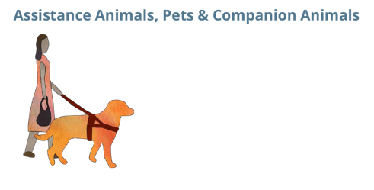

Communicate the plan with the people in your support network and address gaps through collaboration
4

Lots of people have plans “in their heads.” But an effective plan is one that works in practice. Writing it down is not enough. Make time to discuss your situation, your capabilities, and what support you will need in an emergency together with the people in your support network.

You may have to make adjustments to your plan – taking into account who will actually be there when disaster strikes.

Make time to talk about the barriers to preparedness – what are the things that are stopping you from getting prepared? What do you need to happen to help you get to the next stage of preparedness?

Make a list of the GAPS in YOUR preparedness plan. Being clear about what you need will help you to prioritise and plan effectively. It can also help you and others to advocate for the supports you will need in an emergency.

Examples of gaps in emergency preparedness

“Some people didn’t even have a support worker to check in on them. Some of them have a couple different people doing different things for them so they might think, “Oh they might’ve checked in.” So, who’s responsibility is it to check in on that person?”

“What do we do when the support workers are affected by the disaster as well?”

“There’s still that big gap of people who aren’t engaged in any service, who are particularly vulnerable. Who does those check-ups, or check-in’s when it’s someone who is harder to reach?”

“He was best placed in home, in terms of equipment and everything he has it’s all set. But if push comes to shove and the orders coming up, he’s got to go. But how does he get out in terms of his total reliance on a wheelchair, and that access. So, he would have to make a call really early, and so basically, it’s about his support network and thinking ahead around that support network. Yeah, it’s huge for him.”

4

Tips Support from others is important. Talk with others who have responsibility for emergency preparedness
about how those gaps might be addressed.
Talk to Council staff about your needs in emergencies and learn from your Council about the emergency
preparedness plans they have in place.

Emergency Preparedness is a Process!

At the start of her preparedness planning, Ricky Buchanan, Bedridden Disability Advocate felt like this:
“It’s no wonder I end up feeling overwhelmed whenever I try to construct a realistic evacuation or shelter-in-place plan. Those are overwhelmingly awful things to think about that would be life-changing in negative ways. I often describe my disability situation as “fragile” and “prone to breakage.” I’ve spent 20 years in this single home optimising everything so I can function as well as humanly possible given my body’s limitations. Changing even one tiny fragment of the setup causes days and days of symptoms and increased disability. Managing all the things that would change in an actual emergency situation is always going to be overwhelming.”

Five months later, after having engaged in all hazards planning using the P-CEP Toolkit, managing through
Australia’s worst bushfire season, and the current pandemic, Ricky wrote an opinion piece for Every Australian Counts about her experience. It was titled: COVID-19 Contingency Planning: Everything Actually Worked. You can read it here.

At the end of that article, Ricky gave the following advice:
“It’s not too late to make a list of what you need to do in an emergency. Have all the relevant phone
numbers and emails in one place. You don’t want to be searching for things when you are stressed.
Check out the templates and make yourself a little plan. It’s not too late – if you’re like me COVID-19 is
not your only possible emergency.
Talk to someone else about it – so you are not trying to do it all alone. And send it to that trusted person
so someone else has a copy and knows all about it. And share what you are comfortable with your
providers.”

Resources

Australian Red Cross RediPlan Easy English Planning Guide:
https://www.redcross.org.au/getmedia/b9c93efd-6788-4115-b070-6e9714fa4ee7/Easy-English-Rediplan-accessible.pdf.aspx

Carer Ready Guide:
If you are a carer of someone with dementia, you need to think carefully about how best to help them and protect both of you from harm. The Carer Ready Guide can help you think about these issues.
https://dementiakt.com.au/resource/carer-ready-guide/

Disability-Inclusive Disaster Risk Reduction Resources:
https://collaborating4inclusion.org/disability-inclusive-disaster-risk-reduction/

Person-Centred Emergency Preparedness Videos and Information:
https://collaborating4inclusion.org/pcep/

Be aware!
In life threatening emergencies

POLICE/FIRE/AMBULANCE
000

Hearing/Speech Impaired SMS relay number
0423 677 767

Voice Relay number
1300 555 727

TTY number
133 677

National Telephone Interpreter Service
1800 131 450

State Emergency Services (floods and storms) | 132 500
Bushfire Information Line (Fires near me)
Police Assistance (non-emergency)
Life Line – 24 Hour Free Crisis Couselling
My Local Radio Station
My Local Council

Person-Centred Emergency
Preparedness (P-CEP): WORKBOOK

Funding: This project was proudly funded by the Queensland Government through the Queensland Disaster Resilience Fund (QDRF) and the Department of Communities, Disability Services and Seniors.
This project was led by the Centre for Disability Research and Policy in partnership with the Queenslanders with Disability Network and the Community Services Industry Alliance.
Original illustrations of the P-CEP framework, Natural Hazards and Emergency Services by returnstudios.org
Citation: Villeneuve, M., Abson, L., Yen, I., & Moss, M. (2020). Person-Centred Emergency Preparedness (P-CEP) Workbook. Centre for Disability Research and Policy, The University of Sydney, NSW, 2006.
ISSN: 2652-2241, Issue 2/No 1 (Online).
Enquiries should be addressed to:
Associate Professor Michelle Villeneuve
The Centre for Disability Research and Policy,
The University of Sydney, Sydney Australia
Email: michelle.villeneuve@sydney.edu.au
Web: www.collaborating4inclusion.org

